# **Hackathon Project Phases**

## **Project Title:**

## Advancing Nutrition Science through GeminiAI

## **Team Name:** *NutriTech*

## **Team Members:**

* M.Sneha Reddy
* D.Pavani
* A.Bhavya Reddy
* M.Pravalika

## **Phase-1: Brainstorming & Ideation**

### **Objective:**

Develop an AI-powered **nutrition analysis and meal-planning tool** using **Google Generative AI** to provide users with detailed food insights and personalized meal plans.

### **Key Points:**

1. **Problem Statement:**

* Many individuals struggle to access reliable, detailed nutritional information about food items.
* Users find it challenging to create **healthy, balanced, and personalized meal plans** that align with their dietary needs, allergies, and preferences.
* There is a need for a **smart tool** that can provide instant food analysis and **AI-driven meal planning**.

1. **Proposed Solution:**

* A **web-based application** that leverages **Google Generative AI** to analyze food items, providing data on calorie intake and ingredients list for all the recipes.
* An **AI-powered meal planner** that generates **personalized diet plans** based on user input, including dietary restrictions, health conditions, and activity levels.

1. **Target Users:**

* **Health-conscious individuals** looking for accurate nutritional insights.
* **People with dietary restrictions** (e.g., allergies, medical conditions, vegan, keto).
* **Fitness enthusiasts** who want meal plans aligned with their activity levels.
* **Individuals seeking weight management solutions** through balanced diet planning.

1. **Expected Outcome:**

An AI-powered nutrition analysis and meal-planning website providing real-time food insights and personalized diet guidance. Simplifies meal planning and healthy eating. A valuable tool for nutritionists, dieticians, and fitness trainers.

## **Phase-2: Requirement Analysis**

### **Objective:**

Define the technical and functional requirements for the Advancing Nutrition Science

### **Key Points:**

1. **Technical Requirements:**
   * Programming Language: **Python (Flask-cors)**
   * Backend: **Google Gemini API**
   * Frontend: **Html,CSS,JavaScript**
   * Database: **Not required initially (API-based queries)**
   * AI –Based Tools: **Kaggle(Datasets), Google AI studio(Fine tuning)**
2. **Functional Requirements:**

○ **Fetch nutritional data** using Google Generative AI.  
○ **Generate personalized meal plans** based on user input.  
○ Generate the **calorie inake value** for each **particular meal**.

○ Provides **list of ingredients** required for every meal with quantities required.

3. **Constraints & Challenges:**

* + Ensuring real-time updates from **Gemini API**.
  + Handling multiple inputs.
  + Formatting the output for each day.

## **Phase-3: Project Design**

### **Objective:**

Develop the architecture and user flow of the application.

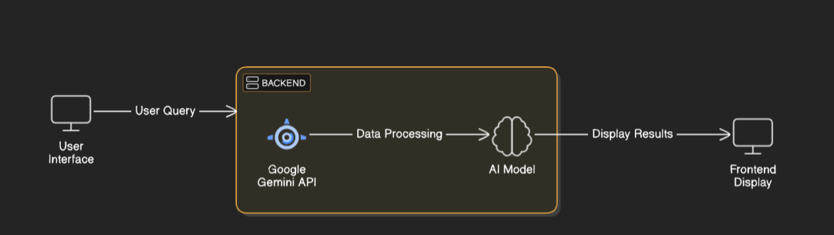

### **Key Points:**

1. **System Architecture:**

○ **User inputs**(e.g., "dietary preferences,allergies,basic details").  
○ **Query is processed using Google Generative AI.**  
○ **AI fetches and analyzes nutritional data.**  
○ **Frontend displays personalized meal plan.**

1. **User Flow:**

○ **Step 1:** User enters the details.  
○ **Step 2:** The backend calls the Gemini AI to generate a meal plan.  
○ **Step 3:** The website processes and displays the meal plan, ingredients to be used,calorie intake per meal.

1. **UI/UX Considerations:**

○ **Clean, intuitive interface** for seamless meal planning.  
○ **Filters for dietary preferences, allergies, and health goals.**  
○ **Easy navigation** throughout the website.

## 

## **Phase-4: Project Planning (Agile Methodologies)**

### **Objective:**

Break down development tasks for efficient completion.

|  |  |  |  |  |  |  |  |
| --- | --- | --- | --- | --- | --- | --- | --- |
| **Sprint** | **Task** | **Priority** | **Duration** | **Deadline** | **Assigned To** | **Dependencies** | **Expected Outcome** |
| Sprint 1 | Environment Setup & API Integration | 🔴 High | 6 hours (Day 1) | End of Day 1 | A.Bhavya Reddy and M.Pravalika | Google API Key, Python | API connection established & working |
| Sprint 1 | Frontend UI Development | 🔴Medium | 2 hours (Day 1) | End of Day 1 | D.Pavani and A.Bhavya  Reddy | API response format finalized | Basic UI with input fields |
| Sprint 2 | Nutritional Data Fetching & Meal Planning | 🔴 High | 3 hours (Day 2) | Mid-Day 2 | M.Sneha Reddy and M.Pravalika | API response, UI elements ready | Meal plans generated with filter |
| Sprint 2 | Error Handling & Debugging | 🔴 High | 1.5 hours (Day 2) | Mid-Day 2 | D.Pavani | API logs, UI inputs | Improved API stability |
| Sprint 3 | Testing & UI Enhancements | 🔴Medium | 1.5 hours (Day 2) | Mid-Day 2 | M.Sneha Reddy | API response, UI layout completed | Responsive UI, better user experience |
| Sprint 3 | Final Presentation & Deployment | 🔴Low | 1 hour (Day 2) | End of Day 2 | Entire Team | Working prototype | Demo-ready project |

### 

### **Sprint Planning with Priorities**

### **Sprint 1 – Setup & Integration (Day 1)**

(🔴 High Priority) Set up the **environment** & install dependencies.  
(🔴 High Priority) Integrate **Google Generative AI**.  
(🔴 Medium Priority) Build a **basic UI** with input fields.

### **Sprint 2 – Core Features & Debugging (Day 2)**

(🔴 High Priority) Implement **nutritional data fetching & meal planning logic**.  
(🔴 High Priority) Debug **API issues & handle incorrect queries**.

### **Sprint 3 – Testing, Enhancements & Submission (Day 2)**

(🔴 Medium Priority) Test **AI-generated meal plans**, refine UI, & fix bugs.  
(🔴 Low Priority) Final **demo preparation & deployment**.

## **Phase-5: Project Development**

### **Objective:**

Implement core features of the Advancing Nutrition Science.

### **Key Points:**

1. **Technology Stack Used:**

* **Frontend:** Html, CSS, Javascript
* **Backend:** Google Gemini Flash API
* **Programming Language:** Python
* **AI –Based Tools**: Kaggle(Datasets), Google AI studio(Fine tuning)

1. **Development Process:**

* **Implement API key authentication and integrate Gemini API.**
* **Develop meal planning, recipe informstion for every meal along with the calorie count per meal.**
* **Optimize food search queries for accuracy and efficiency.**

1. **Challenges & Fixes:**

○ **Challenge:** Handling large user queries efficiently.  
**Fix:** Implement caching for frequently accessed nutritional data.  
○ **Challenge:** Ensuring accurate dietary recommendations.  
**Fix:** Train AI with verified nutritional databases.

## **Phase-6: Functional & Performance Testing**

### **Objective:**

Ensure that the Advancing Nutrition Science works as expected.

|  |  |  |  |  |  |
| --- | --- | --- | --- | --- | --- |
| **Test Case ID** | **Category** | **Test Scenario** | **Expected Outcome** | **Status** | **Tester** |
| TC-001 | Functional Testing | Display calorie intake and ingredients list for meals | AI accurately extracts and displays calorie and ingredient details | ✅ Passed | M.Pravalika |
| TC-002 | Functional Testing | Generate a personalized meal plan based on dietary preferences | AI suggests appropriate meal plans considering all factors | ✅Passed | D.Pavani |
| TC-003 | Performance Testing | API response time under 500ms | API should return results efficiently | ✅Passed | A.Bhavya Reddy |
| TC-004 | Bug Fixes & Improvements | Fixed incorrect nutrient calculations. | Data accuracy should be improved. | ✅ Fixed | M.Sneha  Reddy |
| TC-005 | Final Validation | |  | | --- | | Ensure interactive website design |  |  | | --- | |  | | |  | | --- | | Website should be user-friendly and interactive |  |  | | --- | |  | | ✅Passed | M.Pravalika |